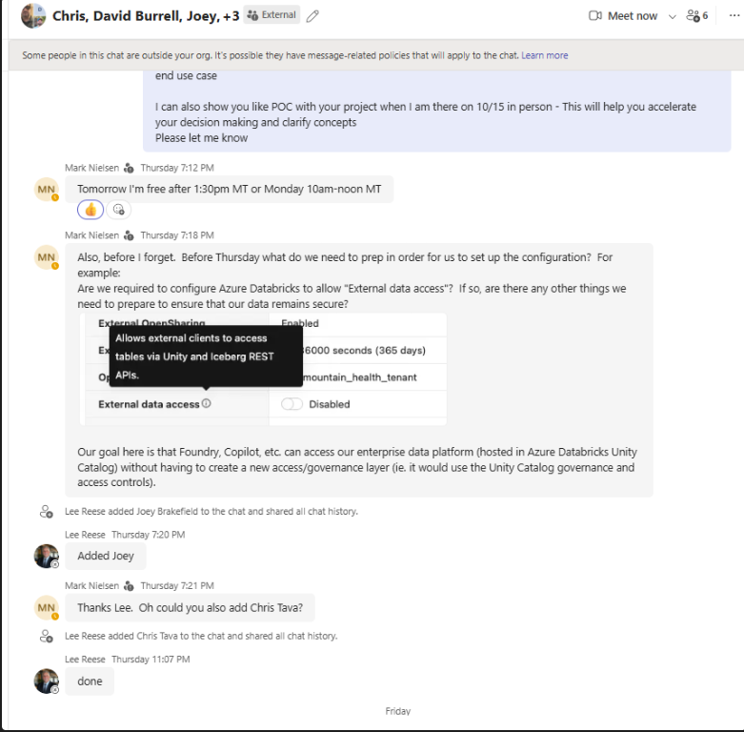
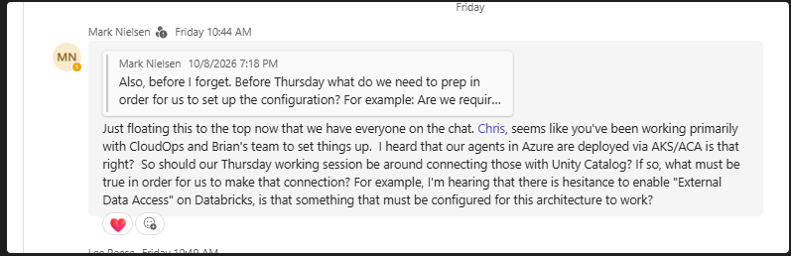
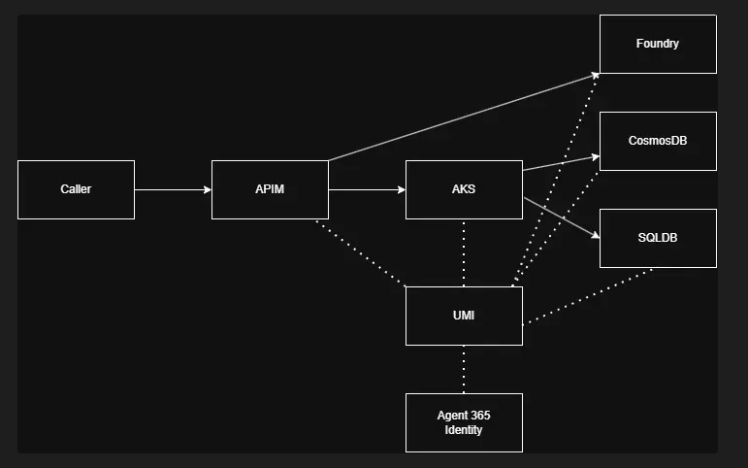
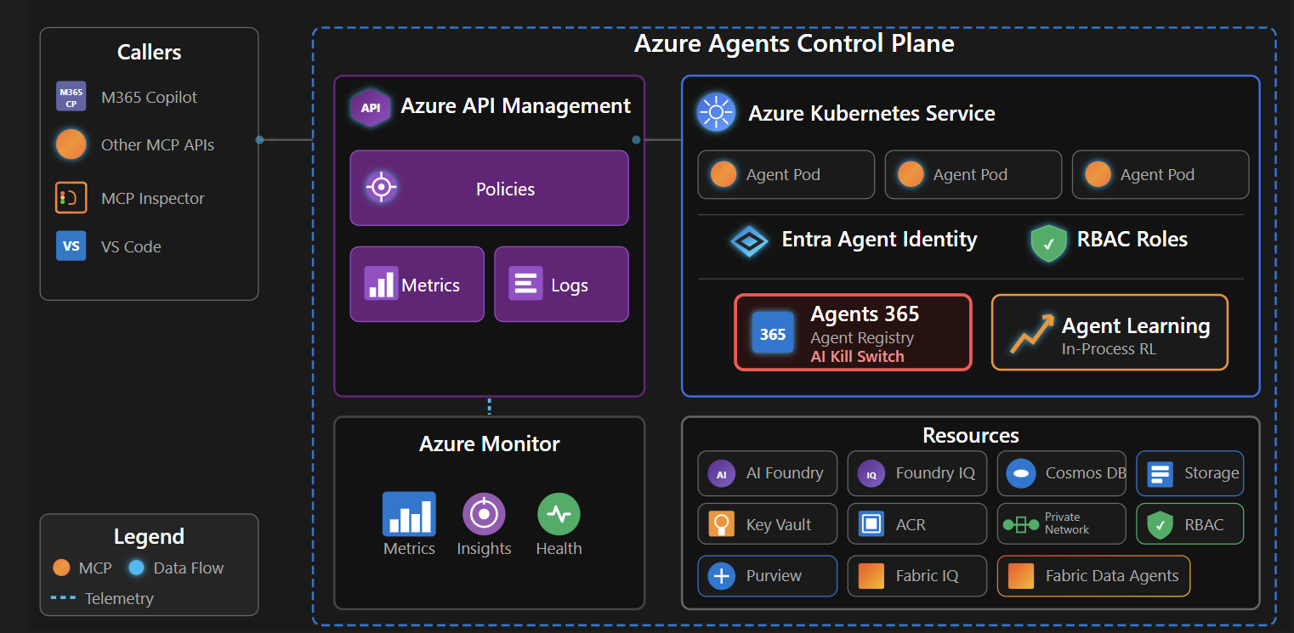
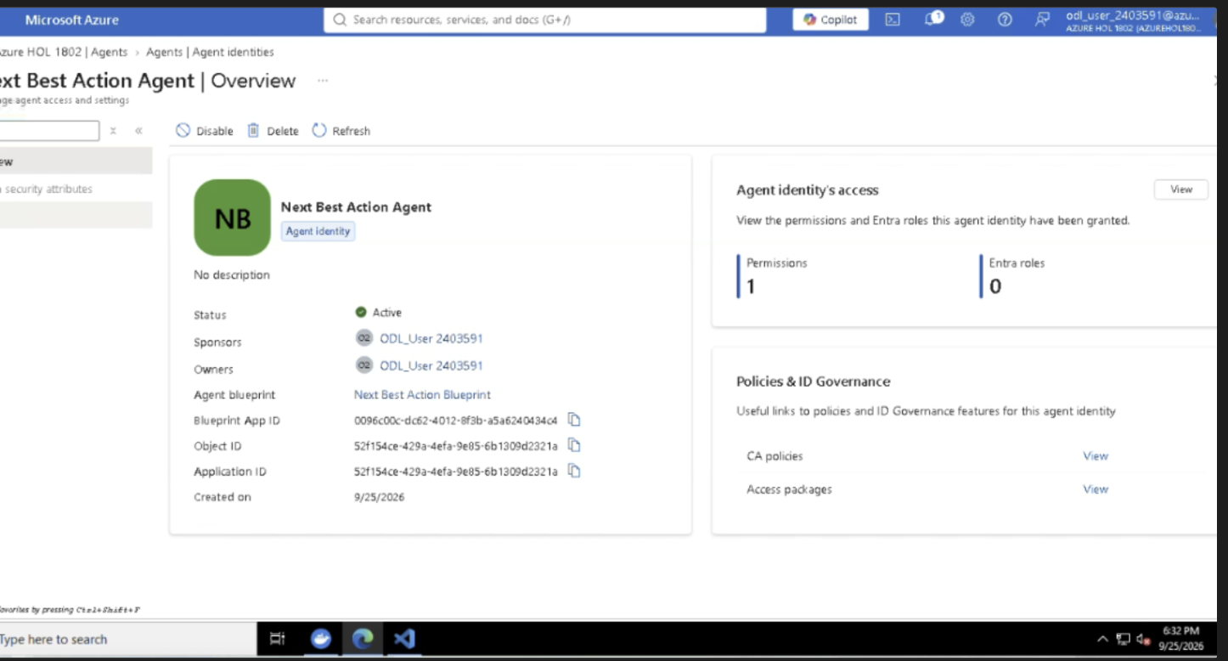
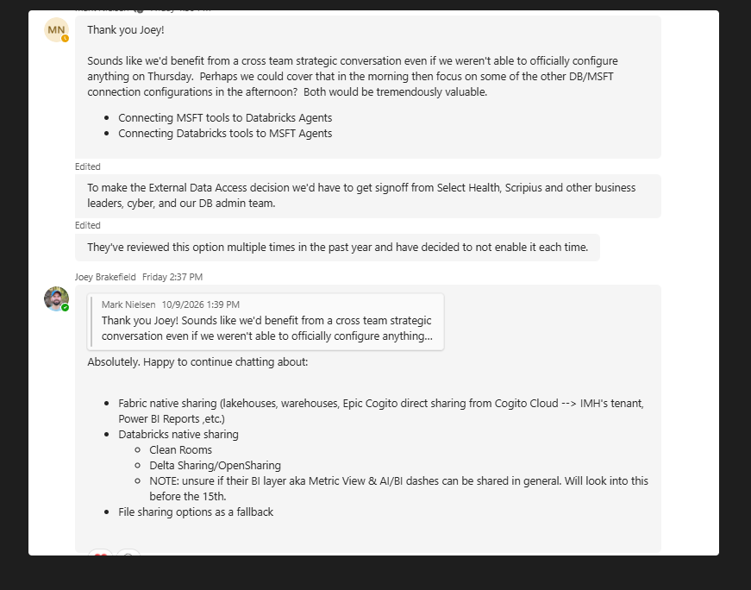
Remember
Mark Nielsen yes, have been working with Brian's team and we've stood up the azure agents control plane with : APIM and AKS.
APIM support MCP based protocol. The resources in Azure are backed by User Managed Identities and can be locked down in Agents 365 with an AI Kill switch:
Agents 365 agent registry showing the Disable kill-switch control
microsoft/azure-agents-control-plane
to have an azure agents connect to databricks constructs we can follow a pattern like this: That would be great! When inviting Intermountain team members to attend this was one of the questions I got as feedback. If by chance we do get stuck where we determine that it does not make sense to enable External Data Access. I think we could pivot the team towards setting up other Unity Gateway/APIM/Foundry integrations. I've got a long list of things that would be worth building out a POC.
Azure Agent → API Management → MCP Server → Unity Catalog Function → Databricks Tables
Hi there
Mark, Chris's proposed APIM/MCP → Unity Catalog function approach doesn't need the External Data Access setting when the function executes inside Databricks. It still needs an authorized identity, the appropriate UC function/data permissions, and network access.
The Fabric Unity Catalog mirroring integration does require External Data Access on the metastore, plus explicit EXTERNAL USE SCHEMA and the normal read grants for the connection identity.
There is also a separate governance decision with Fabric. UC policies and permissions don't automatically carry over, so we would need to configure access in Fabric as well. That needs to be part of the discussion given your goal of avoiding a second governance layer.
I'd keep these as two separate setup paths for Thursday and confirm which one we're configuring before changing the metastore setting.
Fabric prerequisites for EXTERNAL enablement:
Microsoft Fabric Mirrored Catalog From Azure Databricks Tutorial - Microsoft Fabric | Microsoft Lear…
Go through image and chat here - are we covering our demo to include this ? once you say yes, then we can go back to training me

--------- new chat ----
